Exercises 1. Vectors1. Create the vectors:  
(a) (1, 2, 3,…… 19, 20)  
(b) (20, 19,…….. 2, 1)  
(c) (1; 2; 3; : : : ; 19; 20; 19; 18; : : : ; 2; 1)  
(d) (4, 6, 3) and assign it to the name tmp.  
For parts (e), (f) and (g) look at the help for the function rep.  
(e) (4, 6, 3, 4, 6, 3,….. 4, 6, 3) where there are 10 occurrences of 4.  
(f) (4, 6, 3, 4, 6, 3,…….. 4,6, 3, 4) where there are 11 occurrences of 4, 10 occurrences of 6 and 10 occurrences of 3.  
(g) (4, 4,……… 4, 6, 6,……, 6, 3, 3,….., 3) where there are 10 occurrences of 4, 20 occurrences of 6 and 30 occurrences of 3.  
2. Create a vector of the values of ex cos(x) at x = 3, 3.1, 3.2,……, 6.  
3. Create the following vector

4. Calculate the following:

|  |  |
| --- | --- |
| **a)**  100 ∑ (*i*3 + 4*i*2)i=10 | **b)**  25 ∑ ()i=1 |

5. Suppose  
**A** =

**(a)** Check that **A3** = **0** where **0** is a 3 *×* 3 matrix with every entry equal to 0.  
**(b)** Replace the third column of **A** by the sum of the second and third columns.  
**2.** Create the following matrix **B** with 15 rows:  
**B** = $\left[\begin{matrix}10 & -10 & 10 \\ 10 & -10 & 10 \\ ⋯ & ⋯ & ⋯\end{matrix}\right]$

$$\begin{matrix}10 & -10 & 10\end{matrix}$$ Calculate the 3 *×* 3 matrix **B**T**B**. (Look at the help for crossprod.)

1. Create a 6 *×* 6 matrix matE with every entry equal to 0. Check what the functions row and col return when applied to matE. Hence create the 6 *×* 6 matrix:

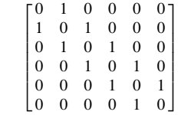

1. Look at the help for the function outer. Hence create the following patterned matrix:

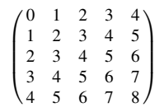

1. Solve the following system of linear equations in five unknowns

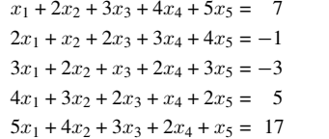

by considering an appropriate matrix equation **Ax** = **y**.  
Make use of the special form of the matrix **A**. The method used for the solution should easily generalise to a larger set of equations where the matrix **A** has the same structure; hence the solution should not involve typing in every number of **A**.

1. The function dim() returns the dimensions (a vector that has the number of rows, then number of  
   columns) of data frames and matrices.
2. Use the functions mean() and range() to find the mean and range of:  
   (a) the numbers 1, 2, . . . , 21  
   (b) the sample of 50 random normal values, that can be generated from a normal distribution  
   with mean 0 and variance 1 using the assignment y <- r norm(50).

(c) applying the functions median() and sum()

1. Run the following code:  
   *> gender <- factor(c(rep("female", 91), rep("male", 92)))  
   > table(gender)  
   > gender <- factor(gender, levels=c("male", "female"))  
   > table(gender)  
   > gender <- factor(gender, levels=c("Male", "female")) # Note the mistake  
   > # The level was "male", not "Male"  
   > table(gender)  
   > rm(gender) # Remove gender*